# P1

1. A to S: Source: 1467, Dest: 23
2. B to S: Source: 1510, Dest: 23
3. S to A: Source: 23, Dest: 1467
4. S to B: Source: 23, Dest: 1510
5. Yes, there’s nothing that stops them from being the same information. There is no relationship between port numbers on different hosts.
6. No, The ports are unique to their processes.

# P2

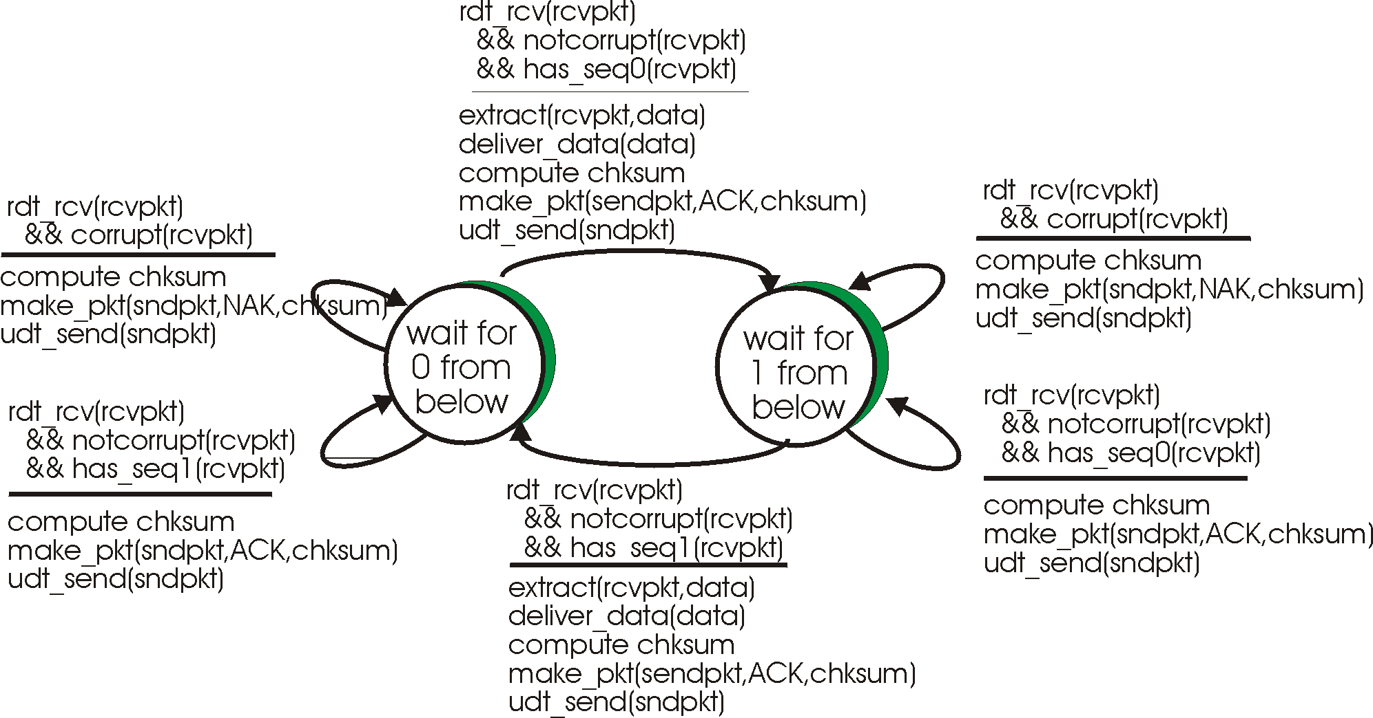

# P3

dtrans = L/R = (1500 * 8 bits/packet)/109 bits/sec = 1.2×10-5 seconds or 12 microseconds

bits = 1500 bytes * 8

t = RTT + L/R = 30.012 msec

98% = .98

n = window

.98 = (.012n)/(30.012) --------- n = 2450.98

window = 2451 packets